# UC-L001 Locum Registration

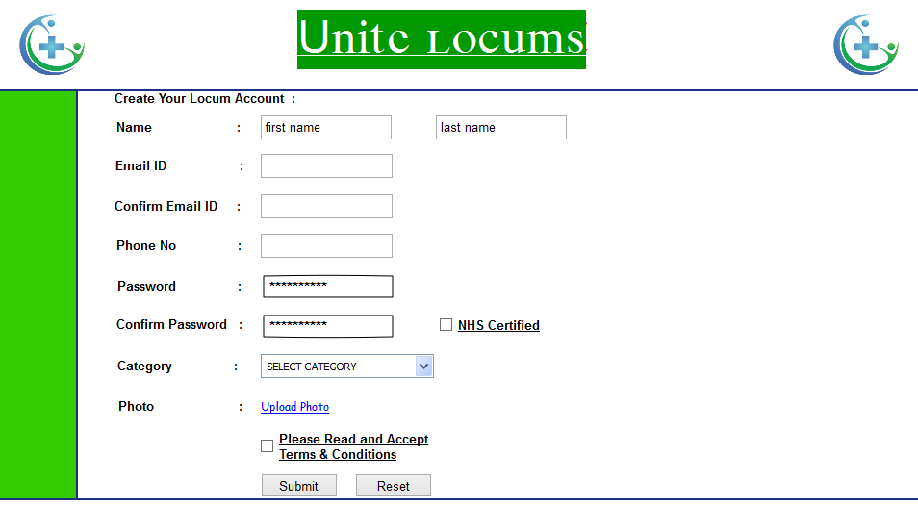

- Category , default to GP – valid values are Dentist, GP , Nurse (Dental) , Nurse (non-Dental) – we need a CATALOGUE form in system

- GMC Number, online check for valid and active in UL DB, any failure should be highlighted to User. This is available only for Locum and Nurse

- Dentist Number, This will become visible only for Dentist Category

- Nurses Number, This will become visible only for both Nurses Category

- Performer List number, online check for valid and active in UL DB, any failure should be highlighted to User. Should come into display only for Locum GP

- EMail id (also used as User Id to login) – Help CONTENT

- Password (show strength indicator - WEAK/MEDIUM/STRONG)

- Alternate EMail Id, (CONTENT to explain User why this is required and how UL will use to send account access details if required)

- Package Selection

-- Basic Package selected as default, some explanation required (CONTENT)

-- Enterprise Package is optional, some explanation required (CONTENT)

- T&C link with a checkbox (CONTENT)

- Capture “how did you hear about us?” – provide a dropdown list of marketing channels - CATALOGUE

- Add random Captcha for added security

On Registration the Account status will be "Active" if all data passed validation, else do not enable the "Register" button

Labels & User Messages should be made configurable wherever possible

On successful Registration system needs to generate email

- System email to UL Admin team to inform new account creation, UL admin to ensure support if required

- Welcome email should to be sent to User (CONTENT)

New accounts will have a set trial offer period in number of days (30) against the account.